Deco Halo Bio

Long Form:

In some ways, it’s a miracle that Deco Halo even exists. I would love to tell you a story of young, hungry up-and-comers, renting a van and driving cross-country to seek their fortune doing what they love. Or a story of seasoned veterans who have released a multitude of albums and performed at highly sought-after venues around the world. But that isn’t this story.

Deco Halo is me (Renee) and Len: two music veterans who have somehow created a partnership that has survived more than 15 years, through band breakups, divorces, relocations, remarriages, and significant changes in musical direction. And while we share a few things in common - love of all genres of music, largely self-taught, strong-willed personalities - we are also quite different. Len likes to have his hands in everything, whereas I am really good at delegating. Len is a composer who writes from the perspective of instrument and mood, while I am a lyricist who writes from the perspective of story and emotion. Neither of us is particularly free with sharing personal information and feelings, and we rarely work in the same room or at the same time on a new song idea. But despite all of this, our ideas always seem to find each other, fitting perfectly together like pieces of a puzzle. Just like we do.

We are now in our 3rd iteration, this time as a musical duo collaborating with musicians all over the world, including Stockholm, Moscow, London, Nashville, New York, Austin, and Rio de Janeiro. This latest collection of songs reflects our love for the interplay between light and dark, sparse and lush, loud and soft, happiness and pain. While some lyrical themes are consistent with previous releases, the music has evolved into more pop/contemporary form, with instrumentation ranging from acoustic guitar to full orchestras.

We will be releasing our latest creations in a series of singles over the course of the next year, through all streaming services. Dear listeners, we hope you enjoy the new direction as much as we have enjoyed creating it.
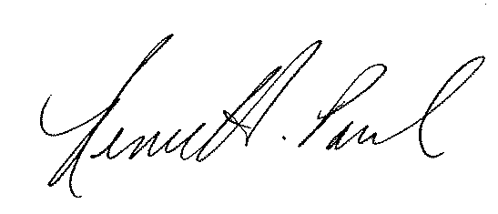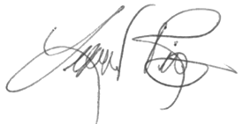

Social Media

Deco Halo is an Ohio-based contemporary pop duo led by Len Rivers and Renee Paul. Their second album is releasing in 2020 as a series of singles.

